KE25 -

Functionality
In this report you can display a specific amount of plan line items in the line item list.

Scenario
Report of all line items coming from billing documents kept in the version ‘Plan version: change 1’ for the whole year 2002 must be prepared.

Requirements
None.

Menu Path | SAP menu → Accounting → Controlling → Profitability Analysis → Information System → Display Line Item List → KE25 - Plan
Transaction Code | KE25

1. Double click on KE25 - Plan

Display Plan Line Items: Initial Screen

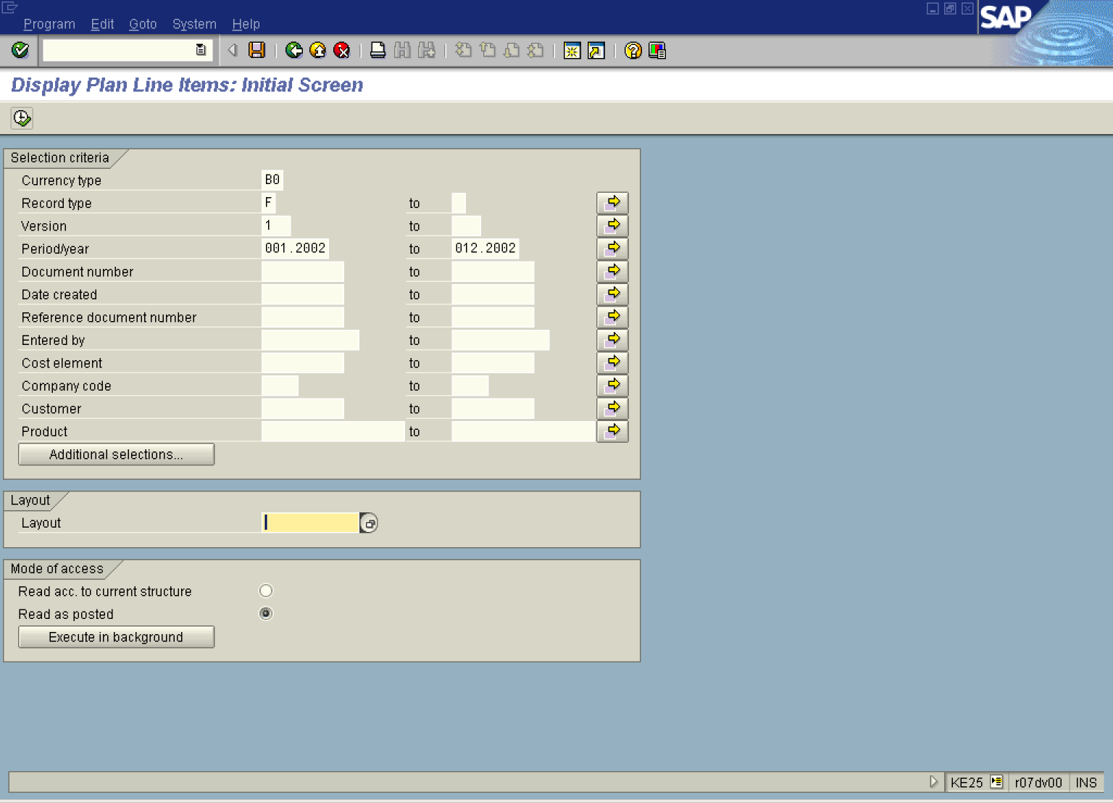

2. Update the following fields:

Field Name | Field Description | Values
Currency type | Code identifying the currency in CO-PA, i.e. ‘B0’ Operating Concern Currency | Example: B0
Record type | Record type, i.e. ‘F’ Billing document | Example: F
Version | Three-digit number which represents the version of the forecast parameters as defined in the forecast profile | Example: 1
Period/year | Period/year, 0MM.YYYY. | Example: 001.2002
To | To Period, 0MM.YYYY | Example: 012.2002

3. Click Layout .

Choose layout (1) 1 Entry found

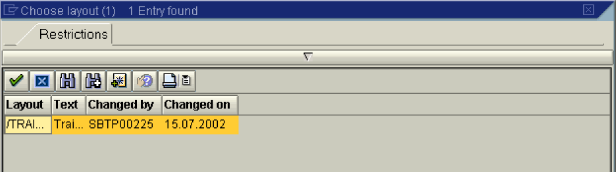

4. Select /TRAI... - in list box.

Display Plan Line Items: Initial Screen

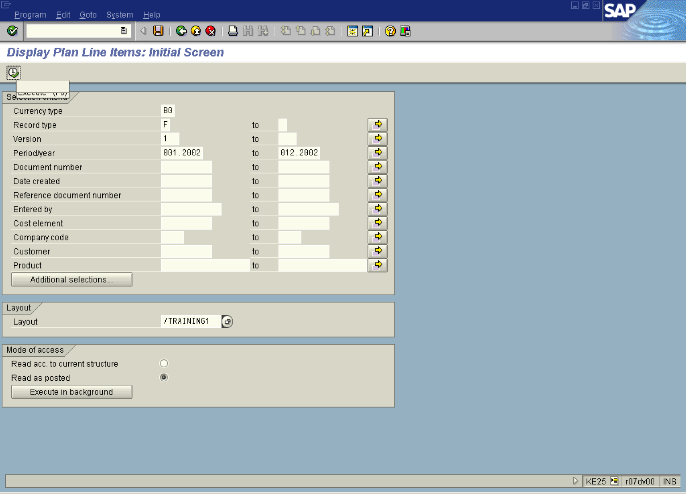

5. Click the Execute button.

Display Plan Line Items: List

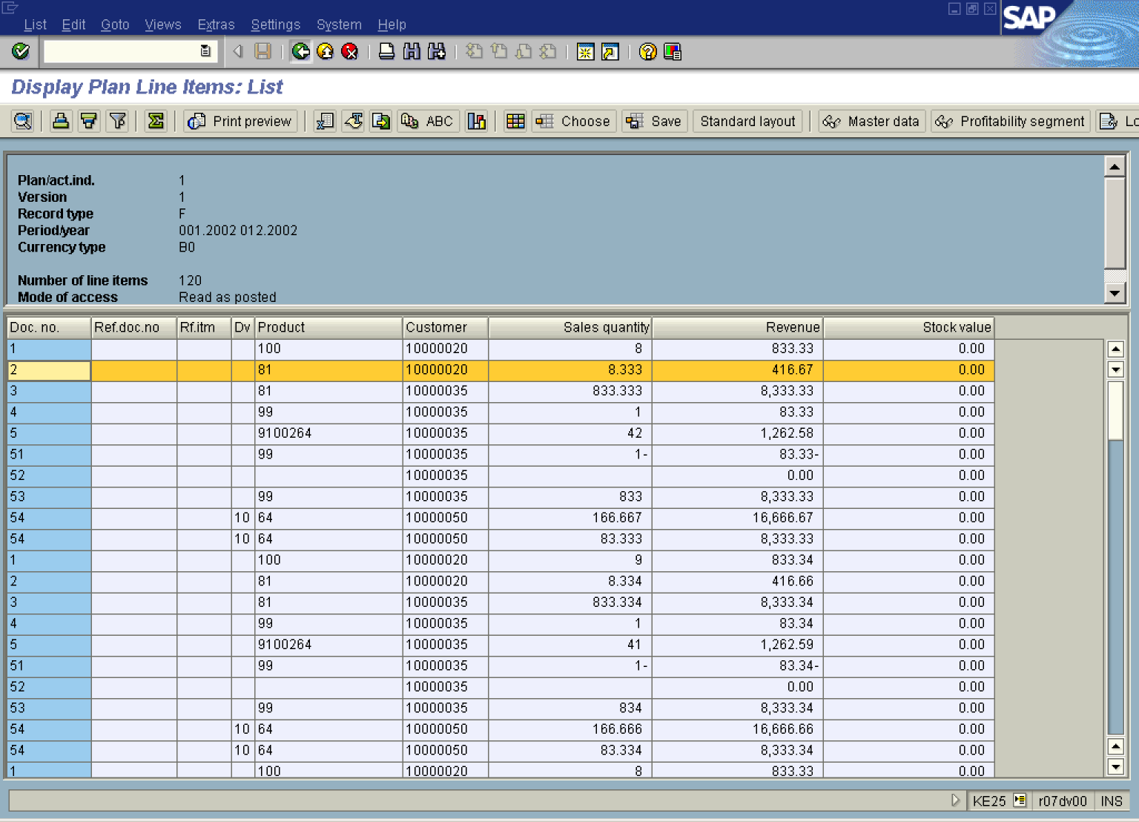

6. Click the Back button.

